**OPERATING SYSTEM - CS23431**

**EXP 2a ROLL NO: 230701047**

**SHELL SCRIPT-BASIC CALCULATOR**

**AIM:**

To write a Shellscript to display basic calculator.

**PROGRAM:**

echo "Enter two numbers"

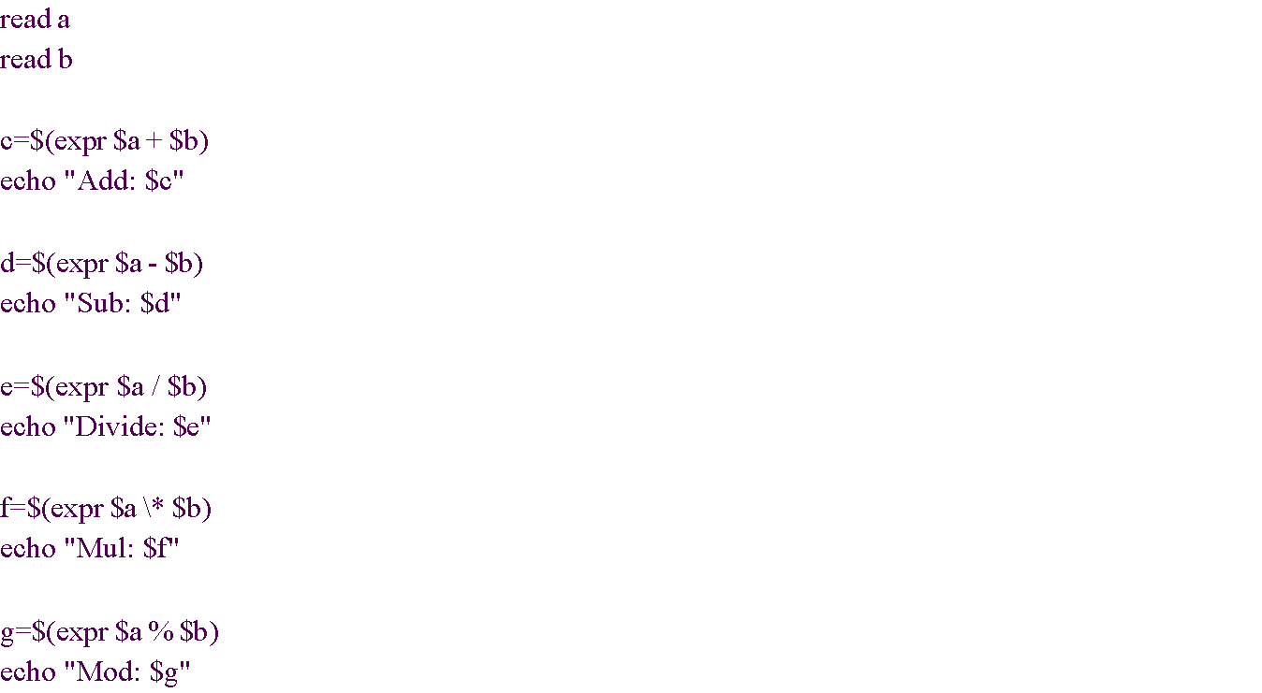

**OUTPUT:**

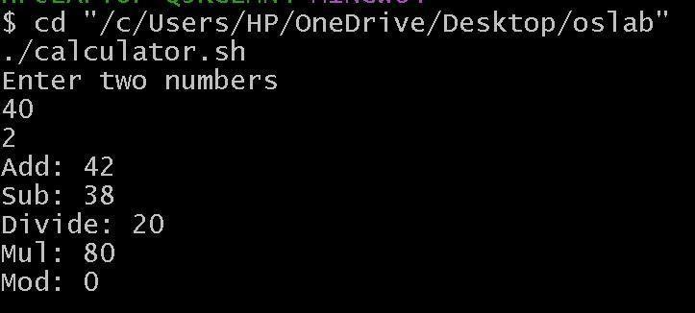

**RESULT:**

The Shellscript for basic calculator was executed and got the output.

**OPERATING SYSTEM - CS23431**

**EXP 2b ROLL NO: 230701201**

**SHELL SCRIPT – LEAP YEAR**

**AIM:**

To write a Shellscript to test given year is leap or not using conditional statement

**PROGRAM:**

echo "Enter year"

read year

